DBMS NOTES

Unit-1: Introduction

1. Overview & File System vs. Database System
Before DBMS, data was stored in traditional File Processing Systems (like individual text or CSV files handled by custom code).

Feature | File System | Database Management System (DBMS)
Data Redundancy | High (same data repeated in multiple files). | Low (centralized control eliminates duplicates).
Data Consistency | Low (updating one file leaves others outdated). | High (updates propagate everywhere automatically).
Data Access | Difficult (requires custom code for every query). | Easy (uses standard query languages like SQL).
Concurrency | Poor (multiple users editing creates conflicts). | Advanced (handles simultaneous updates safely).
Security | File-level permissions only (all or nothing). | Granular (column/row-level permissions per user).
Data Isolation | High (data format is tied to application code). | Low (data is independent of application code).

2. Database System Architecture (Three-Schema Architecture)
To hide technical complexity and keep data separate from user applications, databases use the ANSI-SPARC 3-Level Architecture:
[ External Level ] --> View 1 | View 2 | View 3 (User Views)
|
[ Conceptual Level ] --> Logical Structure (Tables, Relationships, Rules)
|
[ Internal Level ] --> Physical Storage (Files, Indexes, Block Sizes)
- External Level (View Level): What the end-user sees. Tailored views show only relevant data (e.g., a student sees their grades, but not school payroll).
- Conceptual Level (Logical Level): What data is stored and how entities relate. Describes tables, columns, data types, and integrity constraints without worrying about physical disk storage.
- Internal Level (Physical Level): How data is actually saved on the disk (data structures, file paths, indexes, and compression).

Data Independence
The 3-level architecture provides two critical types of data independence:
- Logical Data Independence: Ability to modify the logical schema (e.g., adding a table column) without changing user views or application programs.
- Physical Data Independence: Ability to modify physical storage structures (e.g., changing index types or upgrading hard drives) without altering the logical schema.

3. Database System Concepts
- Data Abstraction: Hiding complex low-level implementation details from users, exposing only simple interfaces to interact with the database.
- Data Dictionary (System Catalog): A specialized database storing metadata (data about data), such as table definitions, user privileges, indexes, and constraints.
- Transactions & ACID Properties: Every database operation must maintain integrity via ACID rules:
  - Atomicity: All operations complete successfully, or none at all (all-or-nothing).
  - Consistency: Database transitions only from one valid state to another valid state.
  - Isolation: Simultaneous transactions run without interfering with each other.
  - Durability: Committed changes persist even in the event of a system crash.

4. Data Models, Schemas, and Instances

Data Model
A conceptual framework or set of tools describing data structure, relationships, semantics, and constraints.
- Relational Model: Data organized into two-dimensional tables (relations) with rows and columns (most common, e.g., PostgreSQL, MySQL).
- ER Model (Entity-Relationship): High-level visual blueprint using Entities (objects), Attributes (properties), and Relationships (connections).
- Object-Based Model: Combines object-oriented programming concepts (classes, inheritance) with database storage.
- Semi-Structured Model: Flexible format where data carries its own structure markers (e.g., JSON, XML).

Schemas vs. Instances
Think of a database like a programming class versus an instantiated object:
- Schema (The Blueprint): The overall logical design and structure of the database. It is defined during database creation and changes very rarely.
  - Example: Student (ID: Integer, Name: String, Age: Integer)
- Instance (The Snapshot): The actual collection of data stored in the database at a specific moment in time. It changes constantly as data is added, updated, or deleted.
  - Example at 10:00 AM: (101, "Alice", 20), (102, "Bob", 22)

1. Data Independence
Data independence is the ability to modify the database schema at one level without forcing changes at higher levels.
- Logical Data Independence: Modifying the conceptual schema (e.g., adding a new column to a table or creating a new table) without needing to rewrite user views or application programs.
  - Example: Adding an email column to a Students table doesn't break an app that only reads name and age.
- Physical Data Independence: Modifying the internal schema (e.g., switching from HDDs to SSDs, changing index structures, or reallocating storage paths) without altering the logical schema or user applications.
  - Example: Changing table storage from B-trees to Hash indexes speeds up queries behind the scenes without changing table structures or SQL syntax.

2. Database Languages & Interfaces
Databases use specific command languages and user interfaces depending on the type of operation needed.

Core Sub-Languages
- Data Definition Language (DDL): Defines and manages the database structure or schema.
  - Commands: CREATE, ALTER, DROP, TRUNCATE.
- Data Manipulation Language (DML): Manages and alters the actual data stored inside tables.
  - Commands: INSERT, UPDATE, DELETE, SELECT (often categorized under DML or DQL).
- Data Control Language (DCL): Controls access rights and permissions for users.
  - Commands: GRANT, REVOKE.
- Transaction Control Language (TCL): Manages transactional state changes to maintain ACID properties.
  - Commands: COMMIT, ROLLBACK, SAVEPOINT.

Database Interfaces
- Menu-based / Web Interfaces: Simple graphical interfaces designed for non-technical users (e.g., online banking apps).
- Form-based Interfaces: Screen fields designed for quick data entry (e.g., job application forms).
- Command Line Interfaces (CLI): Text consoles for database administrators (e.g., mysql or psql prompts).
- Graphical User Interfaces (GUI): Visual tools like pgAdmin or MySQL Workbench for schema creation and querying.
- Application Programming Interfaces (APIs / Embedded SQL): Libraries like JDBC, ODBC, or Python's sqlite3 allowing code to execute database commands programmatically.

3. Data Definition Language (DDL) vs. Data Manipulation Language (DML)

Feature | Data Definition Language (DDL) | Data Manipulation Language (DML)
Target | Database schema and structure. | Records and rows inside tables.
Operations | Creates, alters, or removes database objects. | Adds, updates, deletes, or retrieves data.
Effect | Changes the structural blueprint. | Alters the data instance snapshot.
Persistence | Auto-committed permanently upon execution. | Requires explicit COMMIT to persist in many systems.
Key Commands | CREATE TABLE, ALTER TABLE, DROP TABLE | INSERT INTO, UPDATE, DELETE FROM

4. Overall Database Structure
An end-to-end Database Management System consists of distinct operational components grouped into two main modules: Query Processor and Storage Manager.
[ Users / Apps ] ---> [ Query Processor ] ---> [ Storage Manager ] ---> [ Disk Storage ]

A. Query Processor
Processes incoming commands and translates them into execution plans:
- DDL Interpreter: Parses DDL statements and updates metadata in the data dictionary.
- DML Compiler: Translates high-level DML queries (like SQL) into low-level machine instructions.
- Query Optimizer: Analyzes multiple paths to execute a query and selects the most efficient execution plan.
- Evaluation Engine: Executes the optimized plan generated by the compiler.

B. Storage Manager
Provides the interface between low-level raw data stored on disk and application queries:
- Buffer Manager: Controls caching of data pages in main memory (RAM) to minimize slow disk reads.
- File Manager: Manages allocation of disk space and data structures used to store information on physical storage.
- Authorization & Integrity Manager: Verifies user permissions and validates constraints before executing operations.
- Transaction & Concurrency Manager: Ensures database consistency under concurrent edits and provides recovery mechanisms after system crashes.

1. Core ER Model Concepts
- Entity: A real-world object that is distinguishable from other objects (e.g., Student, Course).
  - Strong Entity: An entity that can be uniquely identified by its own primary key.
  - Weak Entity: An entity that cannot be uniquely identified by its own attributes alone and depends on a strong entity (called the owner entity) via an identifying relationship.
- Attribute: Properties or traits that describe an entity.
  - Simple Attribute: Atomic value that cannot be divided (e.g., Age).
  - Composite Attribute: Can be divided into sub-parts (e.g., Name → First_Name, Last_Name).
  - Single-Valued Attribute: Holds only one value per entity instance (e.g., SSN).
  - Multi-Valued Attribute: Can hold multiple values for a single entity (e.g., Phone_Numbers).
  - Derived Attribute: Computed dynamically from other stored attributes (e.g., Age calculated from Date_of_Birth).
  - Key Attribute: Uniquely identifies each entity instance (e.g., Student_ID).
- Relationship: An association among two or more entities (e.g., Student Enrolls in Course).
  - Cardinality Ratio: Specifies how many entities can relate to another (1:1, 1:N, N:1, M:N).
  - Participation Constraint: Total participation (double line, every entity must participate) vs. Partial participation (single line, optional participation).

2. Notations for ER Diagram (Chen's Notation)
Below are the standard visual symbols used in ER modeling:
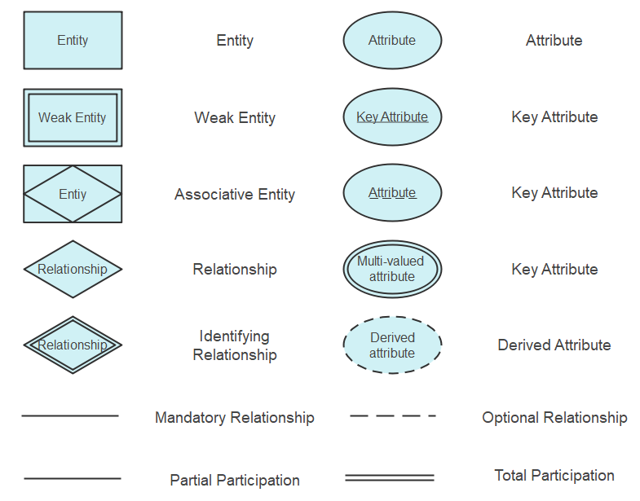
ER Component | Graphical Symbol | Description
Entity Set | Rectangle | Standard strong entity.
Weak Entity Set | Double Rectangle | Depends on a strong entity.
Relationship Set | Diamond | Connection between entities.
Identifying Relationship | Double Diamond | Links a weak entity to its owner entity.
Simple Attribute | Oval | Basic property of an entity.
Key Attribute | Oval with Underlined Text | Primary key identifier.
Multi-valued Attribute | Double Oval | Attribute with multiple possible values.
Derived Attribute | Dashed Oval | Computed from another attribute.
Total Participation | Double Line | All entities must participate in the relationship.
Partial Participation | Single Line | Optional participation in the relationship.

3. Extended ER (EER) Model Concepts
Standard ER diagrams lack features like inheritance and abstraction. The Extended ER (EER) model introduces object-oriented design principles to handle complex applications.

Generalization (Bottom-Up)
Combining multiple entity sets that share common traits into a single higher-level generalized entity set.
- Example: Combining Car and Truck into a higher-level entity Vehicle.

Specialization (Top-Down)
Dividing a higher-level entity set into lower-level sub-entities based on specialized attributes or distinct roles.
- Example: Subdividing Employee into Developer and Manager.

Aggregation
An abstraction process where a relationship between two entities is treated as a single higher-level entity set so it can participate in another relationship.
- Example: Suppose Employee Works_On Project. If we want to assign a Job_Title or Equipment to that specific work assignment, we wrap (Employee - Works_On - Project) inside a box (aggregate) and connect it to Equipment.

4. Relationships of Higher Degree
The degree of a relationship set refers to the number of participating entity sets.
- Unary (Degree 1): A single entity set relates to itself (e.g., Employee manages another Employee).
- Binary (Degree 2): Two entity sets participate (e.g., Student enrolls in Course).
- Ternary (Degree 3): Three entity sets participate simultaneously in a single relationship.
  - Example: Doctor prescribes Medicine to a Patient. All three entities are tied together in one transaction.
- N-ary (Degree N): N entity sets participate simultaneously in a single relationship set.

1. Database Keys
A key is a single attribute or a set of attributes that uniquely identifies a tuple (row) within a relation (table).
+-------------------------------------------------------+
| SUPER KEYS
| (Any set of attributes that uniquely identifies)
|
| +-------------------------------------------+
| | CANDIDATE KEYS
| | (Minimal Super Keys - No redundant)
| |
| | +-------------------------------+
| | | PRIMARY KEY
| | | (Chosen Candidate Key)
| | +-------------------------------+
| +-------------------------------------------+
+-------------------------------------------------------+

Key Concepts & Hierarchy
- Super Key (SK): Any attribute set S⊆R such that no two distinct tuples in relation R have identical values for S. It can contain unnecessary/redundant attributes.
- Candidate Key (CK): A minimal Super Key. An SK K is a candidate key if no proper subset of K is itself a Super Key.
- Primary Key (PK): The specific Candidate Key chosen by the database designer to uniquely identify tuples. It cannot contain NULL values.
- Alternate Key: Any Candidate Key that was not selected as the Primary Key.

Mathematical Definition
Given a relation schema R(A1​,A2​,…,An​) and functional dependencies F:
- X⊆R is a Super Key if X+=R (the attribute closure of X contains all attributes of R).
- X is a Candidate Key if X+=R AND for every Y⊂X, Y+=R.

Worked Example
Consider relation R(A,B,C,D) with functional dependencies:
- A→B
- B→C
- C→D
- Compute (A)+: (A)+={A,B,C,D}. Since it contains all attributes, {A} is a Super Key.
- Is {A} a Candidate Key? Yes, because no proper subset exists (other than the empty set, which cannot determine R).
- {A,B} is a Super Key (since (AB)+={A,B,C,D}), but it is not a Candidate Key because its subset {A} is already a key.

2. Mapping Constraints (Cardinality & Participation)
Mapping constraints define the structural rules for how entities participate in relationships within an Entity-Relationship (ER) model.

Cardinality Ratios (Binary Relationships)
Determines the maximum number of relationship instances an entity can participate in:

Mapping Ratio | Description | Example
1 : 1 (One-to-One) | An entity in A is associated with at most one entity in B, and vice versa. | Department managed by Employee
1 : N (One-to-Many) | An entity in A is associated with many entities in B, but B is associated with at most one in A. | Department employs Employees
N : 1 (Many-to-One) | Multiple entities in A associated with one in B. | Employees belong to Department
M : N (Many-to-Many) | Entities in A and B can be associated with any number of each other. | Students enrolled in Courses

Participation Constraints
- Total Participation (Existence Dependency): Every entity in the entity set MUST participate in at least one relationship instance (represented by double lines in ER diagrams).
- Partial Participation: Some entities in the set may NOT participate in any relationship instance (single line in ER diagrams).

3. Reduction of ER Diagrams to Relational Tables
Converting an ER diagram into a set of relational tables requires specific rules based on entity types and relationship cardinalities to prevent redundancy while preserving constraints.

Rule 1: Strong Entity Sets
Each strong entity set converts into a standalone table.
- Attributes → Columns
- Primary Key → Table Primary Key

Rule 2: Weak Entity Sets
A weak entity cannot exist without an identifying (strong) entity set.
- The weak entity set forms a table containing all its own attributes plus the Primary Key of the identifying strong entity.
- Primary Key: (Identifying Strong PK) + (Weak Entity Partial Key / Discriminator).

Rule 3: Relationship Sets (Based on Cardinality)
- Many-to-Many (M:N):
  - Requires its own standalone table.
  - Columns: Primary keys of both participating entity sets + relationship attributes.
  - Primary Key: Composite key of both foreign keys combined.
- One-to-Many (1:N) or Many-to-One (N:1):
  - No separate table needed (to minimize join overhead).
  - Combine the relationship into the table on the "Many" side.
  - Add the Primary Key of the "One" side as a Foreign Key in the "Many" side table.
- One-to-One (1:1):
  - Total participation on both sides: Combine both entity sets and the relationship into a single table.
  - Total participation on one side: Merge the relationship into the table with total participation by introducing the PK of the other entity as a Foreign Key.
  - Partial participation on both sides: Either merge into one side (introducing FK) or create a separate relationship table (less preferred due to potential NULL values).

Rule 4: Multivalued Attributes
- Create a separate table containing the multivalued attribute and the Primary Key of the parent entity.
- Primary Key: Composite of (Parent PK + Multivalued Attribute).

ER Reduction Summary

ER Element | Relational Schema Rule | Resulting Table PK
Strong Entity | Table per entity | Entity PK
Weak Entity | Table = Weak Attributes + Parent PK | Parent PK + Discriminator
Multivalued Attribute | Table = Parent PK + Attribute | Parent PK + Attribute
M:N Relationship | Separate relationship table | Foreign Keys of both entities combined
1:N Relationship | FK placed inside the "Many" side table | Primary Key of the "Many" side entity
1:1 (Total-Total) | Single merged table | Primary Key of either entity

Unit-2: Relational Data Model & SQL

1. Key Terminology of Relational Data Model
To understand the relational model, you need to know its core building blocks:
- Relation (Table): A two-dimensional table containing rows and columns.
- Tuple (Row): A single row in a table representing a single data record (e.g., one specific student).
- Attribute (Column): A column header that represents a property or characteristic (e.g., Student_ID, Name, Age).
- Domain: The set of all allowed values for an attribute. For example, Age must be a positive integer.
- Degree: The total number of columns (attributes) in a relation.
- Cardinality: The total number of rows (tuples) in a relation.
- Schema: The structure/blueprint of the relation (e.g., Student(Roll_No, Name, Age)).

2. Relational Integrity Constraints
Constraints are rules enforced by the database to ensure that data remains accurate, valid, and consistent.

A. Domain Constraints
- Concept: Ensures that every attribute value in a table belongs to its defined domain (data type and allowable values).
- Rule: Values must be atomic (indivisible) and conform to the correct data type (e.g., integer, text, date).
- Example: An Age column cannot accept string text like "twenty", nor can Phone_Number hold multiple phone numbers in a single cell.

B. Key Constraints
- Concept: Rules that use keys to uniquely identify rows in a table.
- Key Types:
  - Super Key: Any set of attributes that can uniquely identify a row.
  - Candidate Key: A minimal Super Key (a Super Key with no unnecessary attributes).
  - Primary Key: The single Candidate Key chosen by the database designer as the primary unique identifier for each row.
- Rule: No two rows can have identical primary key values.

C. Entity Integrity Constraint
- Concept: Focuses specifically on the Primary Key of a table.
- Rule: The Primary Key column cannot contain NULL values.
- Why? A NULL value means unknown or missing data. If a primary key were NULL, we wouldn't be able to uniquely identify that row.
- Example: In a Student table with Roll_No as the Primary Key, every single student MUST have a non-null Roll_No.

D. Referential Integrity Constraint
- Concept: Maintains consistency between related tables using a Foreign Key.
- Foreign Key (FK): An attribute in one table that references the Primary Key of another table.
- Rule: A Foreign Key value in Table B must either:
  - Match an existing Primary Key value in Table A, OR
  - Be completely NULL (if allowed by business logic).
- Example:
  - Department Table Primary Key: Dept_ID (Values: 10, 20, 30).
  - Employee Table Foreign Key: Dept_ID.
  - An employee cannot be assigned to Dept_ID = 99 because Department 99 does not exist in the Department table.

Summary Table

Constraint | What it enforces | Example
Domain Constraint | Correct data type & single atomic value per cell | Age must be a number
Key Constraint | Uniqueness of row identifiers | No duplicate Student IDs
Entity Integrity | Primary Key cannot be NULL | Every student must have a Student ID
Referential Integrity | Foreign Key must match a valid Primary Key in the target table | Cannot assign a non-existent Department ID to an employee

1. Characteristics of SQL
- Non-Procedural Language: You specify what data you want, not how to retrieve it. The DBMS determines the execution path automatically.
- Declarative and English-Like: Uses plain English words (SELECT, INSERT, WHERE), making it easy to read and learn.
- Set-Oriented Operations: Processes sets of records (tables) at a time rather than row-by-row.
- Standardized: Governed by ANSI (American National Standards Institute) and ISO standards, ensuring consistency across systems like MySQL, PostgreSQL, Oracle, and SQL Server.
- Unified Language: Handles data definition, data manipulation, access control, and transaction control within a single syntax framework.

2. Advantages of SQL
- High Speed and Efficiency: Fast retrieval and manipulation of large volumes of data using optimized query processing.
- No Complex Programming Needed: Complex data operations can be written in a few lines without writing low-level algorithms.
- Interactive & Embedded: Can be run interactively via command line/GUI tools or embedded inside programming languages (Java, Python, C++).
- Portability: Queries written for one RDBMS can generally be ported to another with minimal syntax adjustments.
- Multi-User Access & Security: Supports granular privileges (GRANT/REVOKE) so multiple users can access specific subsets of data securely.

3. SQL Data Types and Literals

A. Common SQL Data Types

Category | Data Type | Description | Example
Numeric | INT / INTEGER | Whole numbers | 101, -45
 | DECIMAL(P, D) / NUMERIC | Exact fixed-point numbers (P=total digits, D=decimal digits) | 199.99
 | FLOAT / REAL | Approximate floating-point numbers | 3.14159
String / Text | CHAR(N) | Fixed-length character string (padded with spaces up to length N) | 'Male'
 | VARCHAR(N) | Variable-length character string (uses only actual length up to N) | 'John Doe'
Date & Time | DATE | Calendar date (YYYY-MM-DD) | '2026-08-18'
 | TIME | Time of day (HH:MM:SS) | '14:30:00'
 | TIMESTAMP | Combined date and time | '2026-08-18 14:30:00'
Boolean | BOOLEAN | Truth values | TRUE, FALSE, NULL

B. SQL Literals
A literal is a fixed value written directly into an SQL statement:
- Numeric Literals: Plain numbers (e.g., 42, 3.14).
- String Literals: Text enclosed in single quotes (e.g., 'Database').
- Date/Time Literals: Date/time strings enclosed in single quotes (e.g., '2026-08-18').
- Null Literal: Represented by the keyword NULL (indicates missing/unknown value).

4. Types of SQL Commands
SQL commands are grouped into five main categories based on their function:

A. DDL (Data Definition Language)
Defines, changes, or drops database structure and schemas.
- CREATE: Creates a new database object (table, view, index).
- ALTER: Modifies the structure of an existing object (e.g., adds a column).
- DROP: Deletes an entire table or object along with its data.
- TRUNCATE: Removes all rows from a table while keeping its structure intact.

B. DML (Data Manipulation Language)
Handles adding, modifying, and removing rows of data inside tables.
- INSERT: Adds new rows to a table.
- UPDATE: Modifies existing data within rows.
- DELETE: Removes specific rows based on a condition.

C. DQL (Data Query Language)
Used strictly to fetch/retrieve data from the database.
- SELECT: Retrieves specified records matching given conditions.

D. DCL (Data Control Language)
Manages user permissions, roles, and access security.
- GRANT: Gives specific access permissions to a user.
- REVOKE: Removes access permissions previously granted.

E. TCL (Transaction Control Language)
Manages transactions (groups of operations) to ensure data integrity.
- COMMIT: Saves all changes made during the current transaction permanently.
- ROLLBACK: Undoes changes made in the current transaction back to the last commit.
- SAVEPOINT: Sets a checkpoint within a transaction to roll back to if needed.

Relational Algebra is procedural (it specifies how to get the result step-by-step).
Relational Calculus is non-procedural / declarative (it specifies what data is needed without stating how to fetch it).

1. Relational Algebra
Relational Algebra uses mathematical operators to take one or two relations (tables) as input and produce a new relation as output.

A. Fundamental (Basic) Operators

Operator | Symbol | Purpose | Example / Expression
Select | σ | Filters rows that satisfy a condition. | σAge>20​(Student)
Project | π | Filters columns and removes duplicates. | πName,Age​(Student)
Union | ∪ | Combines rows from two union-compatible relations. | Student∪Teacher
Set Difference | − | Finds rows in Relation A that are NOT in Relation B. | Student−InactiveStudent
Cartesian Product | × | Combines every row of Table A with every row of Table B. | Student×Course
Rename | ρ | Renames a relation or its attributes. | ρS(ID,Name)​(Student)

B. Derived (Additional) Operators
Operators built by combining fundamental operators for common operations:
- Set Intersection (∩): Returns rows present in both tables (A∩B=A−(A−B)).
- Join (⋈): Combines related rows from two tables based on a condition (Cartesian product followed by Selection).
  - Theta Join (⋈θ​): Joins tables based on any condition (=,<,>,≤,≥).
  - Equi Join: A Theta Join using only the equality (=) operator.
  - Natural Join (⋈): An Equi Join on all common attribute names, removing duplicate columns.
  - Outer Joins (\Leftbowtie, \Rightbowtie, \fullouterjoin): Preserves unmatched rows from the left, right, or both tables by padding with NULL.
- Division (÷): Used for queries involving "for all" or "every" conditions (e.g., Find students enrolled in ALL courses).

2. Relational Calculus
Relational Calculus uses first-order predicate logic to formulate queries. Instead of operational steps, a query is written as a logical predicate condition:
{t∣P(t)}
(Read as: "The set of all elements t such that predicate P(t) is true.")
It is split into two distinct formalisms based on what variables represent:

3. Tuple Relational Calculus (TRC)
In TRC, variables range over entire tuples (rows) of a relation.
- General Form: {t∣P(t)} where t is a tuple variable and P(t) is a logical formula.
- Key Components:
  - t∈Relation: Asserts that tuple t belongs to a specific table.
  - t.Attribute: Accesses a specific column value of tuple t.
  - Quantifiers:
    - Existential Quantifier (∃t): "There exists at least one tuple t..."
    - Universal Quantifier (∀t): "For all tuples t..."
- Example Query: Find the names of all students with Age > 20.
{t.Name∣t∈Student∧t.Age>20}

4. Domain Relational Calculus (DRC)
In DRC, variables range over individual domain values (column components) rather than entire rows.
- General Form: {⟨x1​,x2​,…,xn​⟩∣P(x1​,x2​,…,xn​)}
- Key Components:
  - Variables x1​,x2​,…,xn​ correspond directly to attributes/columns.
  - ⟨x1​,x2​,…,xn​⟩∈Relation: Evaluates to true if the domain value combination exists as a row in the relation.
  - Uses the same quantifiers (∃,∀) applied to domain variables.
- Example Query: Find the names of all students with Age > 20 where Student relation schema is (RollNo,Name,Age).
{⟨n⟩∣∃r,a(⟨r,n,a⟩∈Student∧a>20)}

Summary Comparison

Aspect | Relational Algebra | Tuple Relational Calculus (TRC) | Domain Relational Calculus (DRC)
Approach | Procedural (How) | Non-Procedural (What) | Non-Procedural (What)
Variable Focus | Table transformations | Tuple (Row) variables | Domain (Attribute value) variables
Foundation | Set Theory & Operations | First-Order Predicate Logic | First-Order Predicate Logic
Practical Use | Basis for SQL Query Optimizer | Inspiration for SQL syntax | Basis for Query-By-Example (QBE) languages

Tables, Views, and Indexes Tables
┌──────────────┐
│ Database Objects │
▼ ▼ ▼
│ TABLES │ │ VIEWS │ │ INDEXES │
│ Physical │ │ Virtual │ │ Fast Lookup │
│ Data Storage │ │ Saved Query │ │ Data Structure
Physical storage units holding data organized in rows and columns.
CREATE TABLE Employees (
EmpID INT PRIMARY KEY,
Name VARCHAR(50) NOT NULL,
DeptID INT,
Salary DECIMAL(10, 2)
);

Views
Virtual tables created by running a saved query. Views contain no physical data of their own—they display dynamic data from underlying tables.
CREATE VIEW HighEarners AS
SELECT EmpID, Name, Salary
FROM Employees
WHERE Salary > 75000;

Indexes
Data structures (typically B-Trees) used by the database search engine to quickly locate rows without scanning the entire table.
CREATE INDEX idx_emp_dept ON Employees(DeptID);

2. SQL Operators and Precedence
Operators allow expressions to be combined and evaluated. When an expression contains multiple operators, SQL evaluates them based on Operator Precedence (highest to lowest):

Precedence | Category | Operators | Description
1 (Highest) | Unary | +, -, ~ | Positive/Negative sign, bitwise NOT
2 | Arithmetic | *, /, % | Multiplication, Division, Modulus
3 | Arithmetic | +, - | Addition, Subtraction
4 | Comparison | =, <>, !=, <, >, <=, >= | Basic comparisons
5 | Logical/Range | IS NULL, LIKE, IN, BETWEEN | Pattern matching, set inclusion, range tests
6 | Logical NOT | NOT | Negates logical condition
7 | Logical AND | AND | Evaluates true if both conditions are true
8 (Lowest) | Logical OR | OR | Evaluates true if either condition is true
Note: Parentheses () override standard precedence order.

3. Data Manipulation: Insert, Update, Delete
- INSERT: Adds new records.
INSERT INTO Employees (EmpID, Name, DeptID, Salary)
VALUES (101, 'Alice', 10, 80000);
- UPDATE: Modifies existing records.
UPDATE Employees
SET Salary = Salary * 1.10
WHERE DeptID = 10;
- DELETE: Removes specific records.
DELETE FROM Employees
WHERE EmpID = 101;

4. Aggregate Functions and Queries
Aggregate functions compute a single result from a set of input values across multiple rows.

Common Aggregate Functions
- COUNT(): Counts the number of rows/non-null values.
- SUM(): Calculates total sum of numeric values.
- AVG(): Calculates average value.
- MIN() / MAX(): Returns minimum or maximum value.

Grouping & Filtering Clause Execution Order
When using aggregates, clause execution order matters:
- WHERE: Filters individual rows before aggregation.
- GROUP BY: Groups remaining rows by common values.
- HAVING: Filters aggregate groups after calculation.
SELECT DeptID, AVG(Salary) AS AvgSalary
FROM Employees
WHERE Salary > 30000 -- 1. Filter rows
GROUP BY DeptID -- 2. Group by DeptID
HAVING AVG(Salary) > 60000; -- 3. Filter groups

5. Queries and Subqueries
A Subquery is a SELECT query nested inside another query (such as SELECT, INSERT, UPDATE, or DELETE).

Single-Row Subquery
Returns a single scalar value.
SELECT Name, Salary
FROM Employees
WHERE Salary > (SELECT AVG(Salary) FROM Employees);

Multi-Row Subquery
Returns multiple rows; used with operators like IN, ANY, or ALL.
SELECT Name
FROM Employees
WHERE DeptID IN (SELECT DeptID FROM Departments WHERE Location = 'NY');

Correlated Subquery
Executes once for every row processed by the outer query, referencing outer query attributes.
SELECT e.Name, e.Salary
FROM Employees e
WHERE e.Salary > (
SELECT AVG(Salary)
FROM Employees
WHERE DeptID = e.DeptID
);

6. Joins
Joins combine columns from one or more tables based on a related attribute.
- INNER JOIN: Returns records that have matching values in both tables.
SELECT e.Name, d.DeptName
FROM Employees e
INNER JOIN Departments d ON e.DeptID = d.DeptID;
- LEFT (OUTER) JOIN: Returns all records from the left table, and matched records from the right table.
SELECT e.Name, d.DeptName
FROM Employees e
LEFT JOIN Departments d ON e.DeptID = d.DeptID;
- RIGHT (OUTER) JOIN: Returns all records from the right table, and matched records from the left table.
SELECT e.Name, d.DeptName
FROM Employees e
RIGHT JOIN Departments d ON e.DeptID = d.DeptID;
- FULL (OUTER) JOIN: Returns all records when there is a match in either left or right table.
SELECT e.Name, d.DeptName
FROM Employees e
FULL OUTER JOIN Departments d ON e.DeptID = d.DeptID;
- CROSS JOIN: Produces a Cartesian product of rows from both tables.
SELECT e.Name, d.DeptName FROM Employees e CROSS JOIN Departments d;

7. Set Operations: Union, Intersection, Minus
Set operations combine results from two distinct queries. Both queries must be union-compatible (same number of columns, matching data types in sequence).
- UNION / UNION ALL: Combines results. UNION removes duplicates; UNION ALL retains duplicates.
SELECT Name FROM Employees
UNION
SELECT Name FROM Contractors;
- INTERSECT: Returns only rows returned by both queries.
SELECT EmpID FROM Engineers
INTERSECT
SELECT EmpID FROM Managers;
- MINUS (EXCEPT): Returns rows from the first query that do not exist in the second query.
SELECT EmpID FROM Employees
EXCEPT -- Uses MINUS in Oracle syntax
SELECT EmpID FROM ExEmployees;

8. PL/SQL Programming Constructs: Cursors, Procedures, Triggers
PL/SQL (Procedural Language/SQL) adds procedural flow control (loops, variables, conditions) to SQL.

A. Cursors
A pointer to a memory area (context area) holding the result of a query. Allows row-by-row processing.
- Implicit Cursors: Automatically created by SQL for standard statements (INSERT, UPDATE, DELETE, SELECT INTO).
- Explicit Cursors: Declared and managed manually by the programmer.
DECLARE
v_emp_id Employees.EmpID%TYPE;
v_name Employees.Name%TYPE;
CURSOR c_emp IS SELECT EmpID, Name FROM Employees;
BEGIN
OPEN c_emp;
LOOP
FETCH c_emp INTO v_emp_id, v_name;
EXIT WHEN c_emp%NOTFOUND;
-- Process fetched record
END LOOP;
CLOSE c_emp;
END;

B. Stored Procedures
Reusable, named blocks of code compiled and stored in the database.
CREATE OR REPLACE PROCEDURE GiveBonus (
p_EmpID IN INT,
p_Bonus IN DECIMAL
) IS
BEGIN
UPDATE Employees
SET Salary = Salary + p_Bonus
WHERE EmpID = p_EmpID;
COMMIT;
END GiveBonus;

C. Database Triggers
Special stored procedures executed automatically ("fired") in response to specific database events (e.g., BEFORE or AFTER an INSERT, UPDATE, or DELETE).
CREATE OR REPLACE TRIGGER LogSalaryUpdate
AFTER UPDATE OF Salary ON Employees
FOR EACH ROW
BEGIN
INSERT INTO AuditLog (EmpID, OldSalary, NewSalary, UpdateDate)
VALUES (:OLD.EmpID, :OLD.Salary, :NEW.Salary, SYSDATE);
END;

Unit-3: Database Design & Normalization

Alternative Approaches to Database Design
Database design dictates how real-world data translates into database schemas. Two primary strategies exist:
- Top-Down Approach (ER to Relational Mapping): Start by identifying high-level entities, attributes, and relationships using an Entity-Relationship (ER) Diagram, then map those visual structures directly into relational tables.
- Bottom-Up Approach (Normalization): Start with a single universal relation containing all attributes, identify operational dependencies among attributes, and decompose large tables into smaller, well-structured ones.

Core Math & Logic Concepts

1. Functional Dependencies (FDs)
A Functional Dependency X→Y ("X determines Y") means that if two tuples share the same value for attribute set X, they must share the same value for attribute set Y.
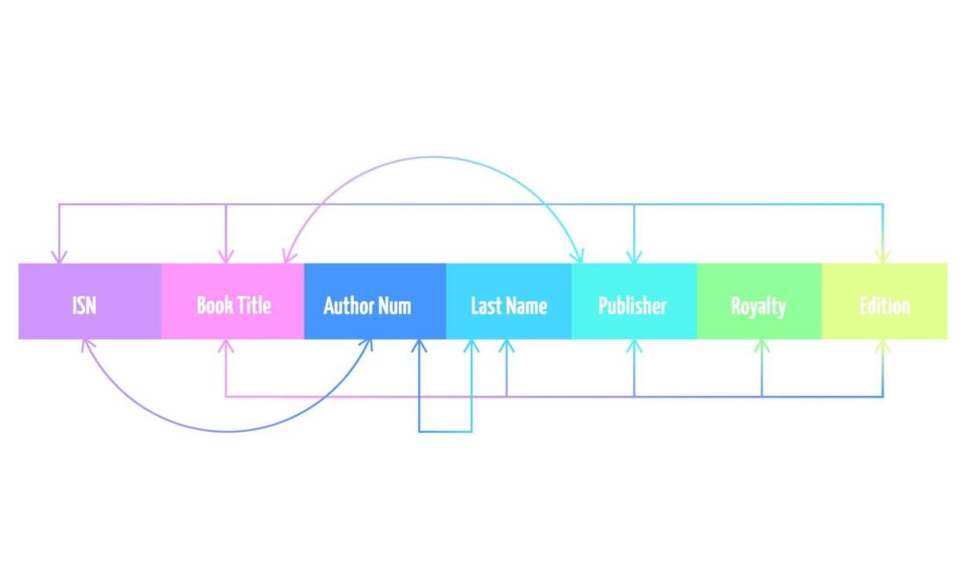
- Types of Attributes:
  - Prime Attribute: An attribute that is part of any candidate key.
  - Non-Prime Attribute: An attribute that is not part of any candidate key.
- Types of FDs:
  - Trivial FD: Y⊆X (e.g., {A,B}→A).
  - Non-Trivial FD: Y⊆X (e.g., A→B).
  - Partial Dependency: A non-prime attribute depends on a proper subset of a candidate key.
  - Transitive Dependency: X→Y and Y→Z, leading to X→Z where Y is a non-prime attribute.

2. Normal Forms (1NF through BCNF)
Normalization cleans up table structure to eliminate update, insertion, and deletion anomalies.
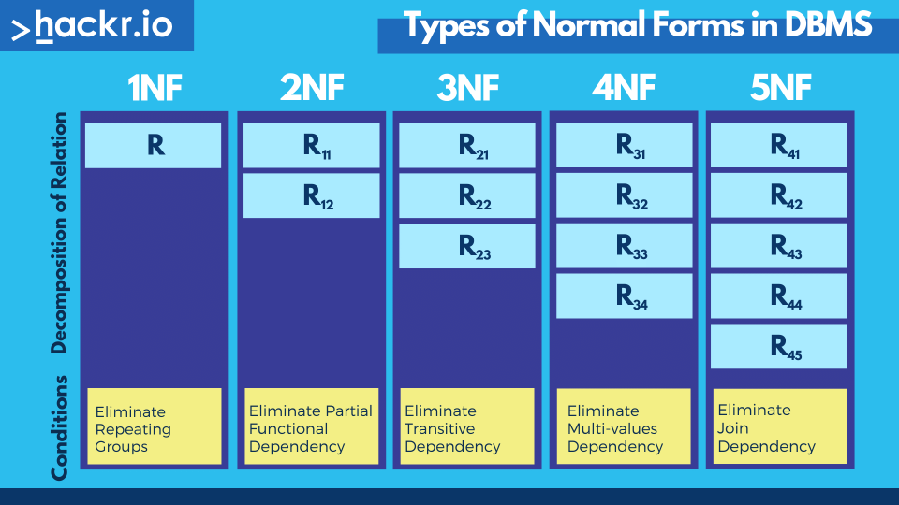
Normal Form | Key Requirement / Constraint | What It Eliminates
1NF | Atomic values only (no sets, lists, or repeating groups). | Non-atomic cell values.
2NF | In 1NF + No Partial Dependencies (non-prime attributes must depend on the entire key). | Partial functional dependencies.
3NF | In 2NF + For every non-trivial X→Y, either X is a Super Key or Y is a Prime Attribute. | Transitive functional dependencies.
BCNF | Strictly stronger than 3NF: For every non-trivial X→Y, X MUST be a Super Key. | Anomalies from overlapping candidate keys.

3. Decomposition & Normalization Properties
When splitting a table R into sub-relations R1​ and R2​:
- Lossless-Join Decomposition: Guarantees that joining R1​⋈R2​ reconstructs the exact original relation R without generating fake ("spurious") rows.
  - Condition: R1​∩R2​→R1​ OR R1​∩R2​→R2​ (the shared attribute set must form a key in at least one sub-relation).
- Dependency Preservation: Guarantees that all functional dependencies of R can be enforced inside R1​ and R2​ independently, without performing expensive cross-table joins.
  - Note: 3NF can always achieve both Lossless Join and Dependency Preservation simultaneously. BCNF guarantees Lossless Join, but might lose dependency preservation.

4. Inclusion Dependencies, MVDs, and JDs
Beyond standard Functional Dependencies, advanced relational design handles higher-order dependencies:
- Inclusion Dependency (ID): Formally represents foreign keys across tables. It states that values in attribute set X of relation R1​ must appear in attribute set Y of relation R2​ (R1​[X]⊆R2​[Y]).
- Multivalued Dependency (MVD): Written as X↠Y. Occurs when X determines a set of independent values for Y, regardless of other attributes.
  - 4NF (Fourth Normal Form): Requires that for every non-trivial X↠Y, X must be a Super Key. Eliminates redundant multi-valued facts in a single table.
- Join Dependency (JD): Generalizes MVDs across multiple tables. Written as ⋆(R1​,R2​,…,Rn​), meaning R can be losslessly reconstructed by joining all n sub-relations together.
  - 5NF / Project-Join Normal Form (PJNF): A table is in 5NF if every Join Dependency in R is implied by its candidate keys. Eliminates remaining cyclic join anomalies.

Unit-4: Transaction Processing Concept

1. Transaction System
A Transaction is a single logical unit of work in a database (e.g., transferring $100 from Account A to Account B).

The ACID Properties
To ensure reliability, every transaction must follow the ACID rules:
- Atomicity (All or Nothing): Either all operations of the transaction complete successfully, or none do. If money leaves Account A, it must arrive in Account B; otherwise, the whole process rolls back.
- Consistency: The database must remain in a valid state before and after the transaction. Total balance across both accounts remains unchanged.
- Isolation: Concurrent transactions run independently without interfering with each other.
- Durability: Once committed, changes are permanent, even if the system crashes a second later.

Transaction States
- Active: Initial state while the transaction executes.
- Partially Committed: Final statement executes, but changes aren't written to disk yet.
- Committed: Changes safely saved to disk.
- Failed: An error occurs during execution.
- Aborted: Transaction rolled back; database restored to its previous state.

2. Recovery from Transaction Failures
Database failures happen due to system crashes, power cuts, software bugs, or media errors. The goal of recovery is to restore Atomicity and Durability.

Types of Failures
- Transaction Failure: Logic error or deadlock causes abort.
- System Crash: Hardware/power failure causes volatile memory (RAM) loss.
- Disk Failure: Storage drive physically breaks.

Two Basic Recovery Operations
- UNDO: Reverts uncommitted changes made by an incomplete transaction.
- REDO: Re-applies committed changes that didn't make it to disk before a crash.

3. Log-Based Recovery
A Log is a sequential, append-only file stored in stable memory. Every database update writes an entry to the log before updating the actual disk—this principle is called Write-Ahead Logging (WAL).

Log Entry Structure
Each record looks like: <Transaction_ID, Data_Item, New_Value Old_Value,>

Log Modifications Approaches
- Deferred Modification:
  - Database disk writes occur only after the transaction commits.
  - Recovery: Never requires UNDO; only needs REDO for committed transactions.
- Immediate Modification:
  - Database disk writes can happen while the transaction runs.
  - Recovery: Requires UNDO for uncommitted transactions and REDO for committed ones.

4. Checkpoints
Scanning a massive log file from the beginning of time after a crash takes way too long. Checkpoints solve this by creating savepoints.

How Checkpointing Works
- Temporarily stops accepting new write requests.
- Flushes all modified RAM data (buffers) and current log records to disk.
- Writes a <CHECKPOINT> record to the log listing active transactions.
- Resumes normal operations.

Recovery Logic using Checkpoints
During recovery, the system scans backward only up to the latest checkpoint:
- Transactions that committed after the checkpoint are REDO'd.
- Transactions that were still active/uncommitted at crash time are UNDO'd.

5. Deadlock Handling
A Deadlock occurs when two or more transactions are stuck forever, each waiting for a resource locked by the other.

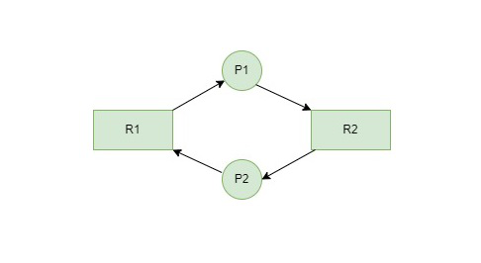Deadlock Handling Strategies

Strategy | Mechanism
Prevention | Uses timestamps to abort transactions before a deadlock can form (Wait-Die or Wound-Wait schemes).
Avoidance | Requires prior knowledge of resource requests to allocate locks safely.
Detection & Recovery | Periodically checks a Wait-For Graph (WFG) for cycles. If a cycle exists, it picks a victim transaction and aborts it.

1. Distributed Database Overview
A Distributed Database (DDBMS) is a single logical database spread across multiple physical computers (nodes/sites) connected via a network. To the user, it feels like using a single local database.

2. Distributed Data Storage
To store data across multiple nodes, DBMS uses two primary techniques: Fragmentation and Replication.

A. Data Fragmentation
Splitting a table into smaller parts (fragments) and placing them on different sites.
- Horizontal Fragmentation: Splits tables by rows based on conditions (e.g., storing Customers where Region = 'US' on Node 1, and Region = 'EU' on Node 2).
- Vertical Fragmentation: Splits tables by columns, keeping the primary key in every fragment so they can be rejoined later.
- Mixed/Hybrid Fragmentation: Combines both horizontal and vertical splitting.

B. Data Replication
Copying the same data fragment across multiple nodes to improve read performance and fault tolerance.
- Full Replication: Every site stores a complete copy of the database (High availability, but heavy storage & update costs).
- Partial Replication: Only frequently accessed tables/fragments are copied to multiple sites.
- No Replication (Non-replicated): Each fragment exists on exactly one site.

3. Distributed Concurrency Control
When multiple transactions execute simultaneously across different sites, we must ensure Isolation and Consistency.

Key Challenges
- Transactions need locks on multiple sites.
- Network delays and message loss make lock coordination harder.

Main Techniques

1. Distributed Locking Schemes
- Single-Lock Manager (Centralized): One central site manages all locks. Simple, but creates a single point of failure and bottleneck.
- Primary Copy: For replicated data, one designated site holds the "primary copy." All write locks must be requested from this site.
- Distributed Lock Manager (Majority Protocol): A transaction requests locks from a majority of sites holding a replica. Prevents single-point failure.

2. Two-Phase Commit Protocol (2PC)
Ensures Atomicity across multiple nodes during a distributed transaction. It uses a Coordinator node and multiple Participant nodes.
Coordinator Participants
│ │
│─────── Prepare Msg ────────>│ (Phase 1: Voting)
│<────── Ready / Abort ───────│
│ │
│─────── Commit / Abort ─────>│ (Phase 2: Execution)
│<────── Acknowledged ────────│
- Phase 1 (Prepare): Coordinator asks all participants, "Are you ready to commit?" Participants log their changes and vote Yes or No.
- Phase 2 (Commit/Abort):
  - If ALL vote Yes → Coordinator sends Commit.
  - If ANY votes No → Coordinator sends Rollback/Abort.

4. Directory System (Data Catalog)
A Distributed Data Directory holds metadata—information about the database structure and where each fragment or replica is physically located.

What It Stores
- Fragment definitions (horizontal/vertical rules).
- Physical mapping (which site holds which fragment).
- Access rights and security permissions.

Types of Directory Architectures

Architecture | Description | Pros | Cons
Centralized | One site stores the whole directory. | Easy to update and search. | Bottleneck and single point of failure.
Fully Replicated | Every site keeps a complete copy of the directory. | Blazing fast local lookups. | Heavy network overhead to update directory entries.
Distributed (Partitioned) | Each site stores location metadata for its local data only. | Highly scalable. | Remote lookups require querying multiple sites.

1. Serializability of Schedules
When multiple transactions run concurrently, their operations (reads/writes) interleave.
- Serial Schedule: Transactions execute one after another without interleaving. Guaranteed to be consistent, but slow.
- Non-Serial Schedule: Operations of multiple transactions overlap. Fast, but risks data inconsistency.
- Serializable Schedule: A non-serial schedule that produces the exact same output as some serial schedule.

2. Conflict & View Serializable Schedules

A. Conflict Serializability
A schedule is Conflict Serializable if it can be transformed into a serial schedule by swapping non-conflicting operations.
Two operations are in conflict if they meet three conditions:
- They belong to different transactions.
- They access the same data item.
- At least one of them is a Write (W) operation.

Conflicting Pairs:
- Read-Write (R1​(A) and W2​(A))
- Write-Read (W1​(A) and R2​(A))
- Write-Write (W1​(A) and W2​(A))

B. View Serializability
View serializability is a broader concept than conflict serializability. Every conflict serializable schedule is view serializable, but not vice versa.
Two schedules S1​ and S2​ are View Equivalent if they satisfy three conditions:
- Initial Read: If Ti​ reads data item A first in S1​, Ti​ must read A first in S2​.
- Final Write: Whichever transaction performs the final write on A in S1​ must perform the final write on A in S2​.
- Updated Read (Read-From): If Ti​ reads A updated by Tj​ in S1​, Ti​ must read A updated by Tj​ in S2​.
Key Rule: A schedule that is View Serializable but NOT Conflict Serializable must contain at least one Blind Write (a write operation performed without reading the item first).

3. Testing for Serializability
To test if a schedule is Conflict Serializable, we construct a Precedence Graph (Serialization Graph).

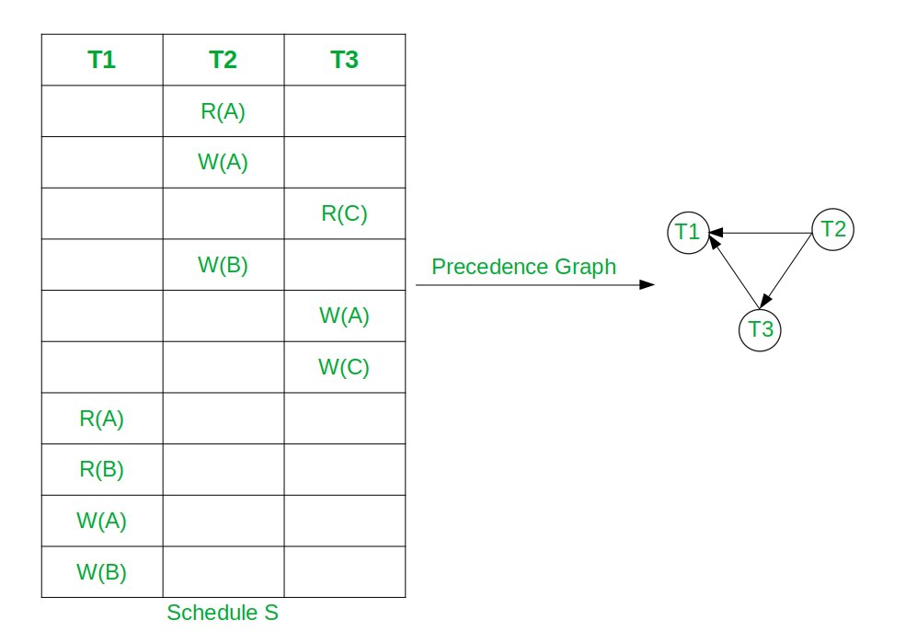Steps to Build a Precedence Graph:
- Nodes: Create a node for each transaction (T1​,T2​,T3​,…).
- Edges: Draw a directed edge Ti​→Tj​ if Ti​ executes a conflicting operation on data item A before Tj​.

Decision Rule
- No Cycle in Graph → Conflict Serializable. (The serial order is given by the Topological Sort of the graph).
- Cycle Present in Graph → NOT Conflict Serializable.

4. Recoverability of Schedules
Even if a schedule is serializable, it must be safe from transaction failures and dirty reads.
Recoverable Schedules
└── Cascadeless Schedules
└── Strict Schedules (Most Safe)

Schedule Type | Condition | Purpose
Recoverable | If Tj​ reads data written by Ti​, then Ti​ must commit before Tj​ commits. | Prevents inconsistent states if Ti​ aborts after Tj​ commits.
Cascadeless | Tj​ can only read data written by Ti​ after Ti​ has committed. | Prevents cascading rollbacks (where aborting one transaction forces many others to abort).
Strict | Tj​ can neither Read nor Write data written by Ti​ until Ti​ commits or aborts. | Easiest to recover using standard UNDO/REDO logs.

Unit-5: Concurrency Control Techniques

1. Concurrency Control Fundamentals

Why Do We Need Concurrency Control?
Without concurrency control, simultaneous transactions lead to three major database anomalies:
- Lost Update Problem: Transaction A and Transaction B read the same data. Both modify it, but whichever writes last overwrites (and erases) the changes made by the other.
- Uncommitted Dependency (Dirty Read): Transaction A updates a row, but hasn't committed yet. Transaction B reads that uncommitted data. Then, Transaction A rolls back (cancels). Transaction B just acted on data that never officially existed.
- Inconsistent Retrievals (Non-repeatable Read): Transaction A reads a row. Transaction B alters or deletes that row and commits. Transaction A reads the same row again and gets a completely different value.

What is Serializability?
The goal of concurrency control is to allow transactions to execute concurrently while ensuring the final outcome is identical to executing them one after another (serially).
- Conflict Serializability: Two operations conflict if they belong to different transactions, access the same data item, and at least one of them is a WRITE operation. If a concurrent schedule can be transformed into a serial schedule by swapping non-conflicting operations, it is conflict serializable.

2. Locking Techniques for Concurrency Control
Locks prevent conflicting transactions from accessing data simultaneously by restricting access to a data item (database, table, or row).

Lock Types (Modes)
- Shared Lock (S): Used for reading data. Multiple transactions can hold a shared lock on the same data item at the same time.
- Exclusive Lock (X): Used for writing/modifying data. Only one transaction can hold an exclusive lock at a time. No other transaction can read or write until the lock is released.

Lock Granted? | Requesting Shared (S) | Requesting Exclusive (X)
Held Shared (S) | Granted | Denied
Held Exclusive (X) | Denied | Denied

Two-Phase Locking Protocol (2PL)
2PL is a protocol that guarantees conflict serializability. Every transaction must acquire and release locks in two distinct phases:
- Growing Phase: The transaction acquires locks as needed. It cannot release any locks during this phase.
- Shrinking Phase: The transaction releases locks. Once it releases its first lock, it cannot acquire any new locks.
Number of Locks
| /-------------\ (Growing Phase Ends)
| / \
| / \ (Shrinking Phase)
| / \
+----------------------------> Time

Variations of 2PL
- Strict 2PL: Holds all exclusive locks (X) until the transaction completely finishes (commits or aborts). Prevents dirty reads.
- Rigorous 2PL: Holds all locks (S and X) until the transaction finishes. Ensures complete isolation.

The Problem with Locks: Deadlock & Starvation
- Deadlock: Occurs when Transaction A waits for a lock held by Transaction B, and Transaction B waits for a lock held by Transaction A. Neither can proceed.
  - Resolution: Deadlock Detection (wait-for graphs) or Deadlock Prevention (time-based priority rules).
- Starvation: Occurs when a transaction is repeatedly denied a lock because higher-priority or faster transactions keep acquiring it.

3. Timestamping Protocols for Concurrency Control
Timestamp protocols do not use locks. Instead, they use time-based ordering to determine which transaction gets priority.

Basic Timestamp Ordering (TO) Protocol
Every transaction T is assigned a unique timestamp TS(T) when it enters the system (using system clock or a logical counter). If TS(T1​)<TS(T2​), then T1​ is older and must be processed first.
Each data item X maintains two values:
- Read_TS(X): The largest timestamp of any transaction that successfully read X.
- Write_TS(X): The largest timestamp of any transaction that successfully wrote X.

The Timestamp Rules
When T tries to READ X:
- If TS(T)<Write_TS(X): T is trying to read a value that was already overwritten by a younger transaction. → Roll back and restart T.
- Otherwise: The read is allowed, and Read_TS(X) is updated to max(Read_TS(X),TS(T)).
When T tries to WRITE X:
- If TS(T)<Read_TS(X): A younger transaction has already read X before T got to write it. → Roll back and restart T.
- If TS(T)<Write_TS(X): A younger transaction has already written a newer value to X. → Roll back and restart T (Note: Thomas' Write Rule overrides this condition).
- Otherwise: The write is allowed, and Write_TS(X) is updated to TS(T).

Thomas' Write Rule
An optimization of basic timestamping for WRITE requests:
- If TS(T)<Write_TS(X), instead of rolling back T, the system simply ignores (discards) T's write operation.
- Why? Because a younger transaction has already written a newer value, so T's write is obsolete anyway. This saves unnecessary rollbacks.

Strict Timestamp Ordering
Ensures that transactions read only committed data:
- If T wants to read or write X, and Write_TS(X) belongs to an uncommitted transaction, T must wait until that transaction commits or aborts.

Validation-Based Protocol (Optimistic Concurrency Control)
Validation-based protocols assume that most transactions will not conflict with each other (hence "optimistic"). Instead of locking data items before accessing them, transactions execute freely in local memory and are only validated before committing.

The 3 Phases of a Transaction
- Read & Execution Phase:
  - The transaction reads data from the database.
  - All updates/writes are performed only on local temporary copies of the data, not on the actual database.
- Validation Phase:
  - The system checks whether the transaction's temporary updates violate serializability with any concurrent transactions.
  - If validation succeeds, the updates are allowed to proceed to Phase 3.
  - If validation fails, the transaction is rolled back (aborted) and restarted.
- Write Phase:
  - The validated updates are written from local temporary variables into the actual database.

Transaction Timestamps in Validation
Each transaction Ti​ is assigned three timestamp checkpoints:
- Start(Ti​): When Ti​ starts execution.
- Validation(Ti​): When Ti​ finishes its read phase and starts validation. This timestamp determines the serializability order.
- Finish(Ti​): When Ti​ completes its write phase.

Validation Test Rules
For Ti​ to pass validation against an older transaction Tk​ (Validation(Tk​)<Validation(Ti​)), one of the following two conditions must hold:
- Finish(Tk​)<Start(Ti​): Tk​ completed its entire execution before Ti​ even started.
- The set of data items written by Tk​ does not overlap with the set of data items read by Ti​, and Tk​ finishes its write phase before Ti​ starts its validation phase (Finish(Tk​)<Validation(Ti​)).

2. Multiple Granularity Locking
Granularity refers to the size of the data item being locked (Database → File/Table → Page → Record/Row).
- Fine Granularity (e.g., Row level): High concurrency, but high overhead because the system manages thousands of locks.
- Coarse Granularity (e.g., Database/Table level): Low overhead, but low concurrency because locking a table locks out everyone else.
Multiple Granularity allows the DBMS to lock data items at different hierarchical levels simultaneously using a tree structure.
Database
|
Table
|
Page
|
Record

Intent Locks
To lock a fine-grained node (like a Record), a transaction must first place an Intent Lock on all parent nodes (Page, Table, Database) to signal its intentions down the hierarchy. This prevents another transaction from locking an entire table when a single record in it is already locked.
- Intent-Shared (IS): Explicit locking is taking place at a lower level of the tree, but only with Shared locks.
- Intent-Exclusive (IX): Explicit locking is taking place at a lower level with Exclusive or Shared locks.
- Shared & Intent-Exclusive (SIX): The subtree rooted at this node is locked explicitly in Shared mode, AND explicit Exclusive locking is taking place at lower levels.

Lock Compatibility Matrix

Held \ Requested | IS | IX | S | SIX | X
IS | OK | OK | OK | OK | No
IX | OK | OK | No | No | No
S | OK | No | OK | No | No
SIX | OK | No | No | No | No
X | No | No | No | No | No

Rules for Locking
- Locks must be acquired from top to bottom (Database down to Record).
- Locks must be released from bottom to top (Record up to Database).

3. Multi-Version Schemes (MVCC)
Multi-Version Concurrency Control (MVCC) ensures that readers never block writers, and writers never block readers.

How MVCC Works
Instead of overwriting existing data during a WRITE operation, the system creates a new timestamped version of that data item.
- When a transaction performs a READ, it is directed to the latest version of the data item whose timestamp is older than or equal to the transaction's timestamp.
- When a transaction performs a WRITE, it creates a brand-new version tagged with its timestamp.

Multiversion Timestamp Ordering
Each version Qk​ of a data item Q maintains three attributes:
- Value: The actual stored data.
- W-timestamp: The timestamp of the transaction that created version Qk​.
- R-timestamp: The largest timestamp of any transaction that successfully read version Qk​.
Rules for Transaction Ti​:
- Read Operation: Ti​ reads the version Qk​ whose W-timestamp is the largest timestamp less than or equal to TS(Ti​). Then R-timestamp of Qk​ is updated to max(R-timestamp(Qk​),TS(Ti​)).
- Write Operation:
  - If Ti​ tries to write Q, but a transaction Tj​ with TS(Tj​)>TS(Ti​) has already read a version of Q that Ti​ should have overwritten (i.e., TS(Ti​)<R-timestamp(Qk​)), then Ti​ is rolled back.
  - Otherwise, Ti​ creates a brand-new version of Q with W-timestamp = R-timestamp = TS(Ti​).

Recovery with Concurrent Transactions
When multiple transactions execute concurrently, simple recovery methods (like restoring from a backup and redoing everything) become too slow or complex. DBMS recovery mechanisms rely on log-based recovery, shadow paging, and specialized algorithms to handle concurrent rollbacks without losing committed data.

The Log File and WAL (Write-Ahead Logging)
Every state change made by a transaction is recorded in an append-only log before it is applied to the database disk.
- WAL Protocol: Log records representing a data modification must be written to disk before the actual data page is flushed to disk.
- Log Record Structure: Contains [Transaction_ID, Data_Item, Old_Value, New_Value].

Checkpointing
If a system crashes, scanning the entire log file from the beginning of time is impossible. Checkpointing periodically saves the database state to narrow down how much log needs to be scanned during recovery.
- Simple Checkpoint: Suspends all execution, flushes all dirty memory buffers to disk, writes a <CHECKPOINT> record to the log, and resumes execution. (High overhead/downtime).
- Fuzzy Checkpoint: Allows active transactions to continue running while flushing dirty pages to disk in the background.

Failure Classifications During Concurrent Execution
When a crash occurs with concurrent transactions running, active transactions must be handled based on whether they were committed or uncommitted at crash time:
Timeline:
T1 |----------------------- (Committed before Checkpoint)
T2 |--------------------------- (Committed before Crash)
T3 |--------------------------> [CRASH]
T4 |--------------------> [CRASH]
Checkpoint Crash Point
- T1: Committed before the checkpoint. No action needed (already on disk).
- T2: Started before checkpoint, committed before crash. Must be REDO-ed.
- T3: Started before checkpoint, active during crash. Must be UNDO-ed.
- T4: Started after checkpoint, active during crash. Must be UNDO-ed.

Recovery Algorithms: ARIES (Algorithms for Recovery and Isolation Exploiting Semantics)
ARIES is the standard recovery framework for concurrent databases. It executes in 3 Phases after a crash:
- Analysis Phase:
  - Scans the log forward from the last checkpoint.
  - Identifies all active transactions (dirty/uncommitted) at the time of the crash (the "loser" transactions) and all dirty pages in memory.
- Redo Phase:
  - Scans forward from the oldest unwritten change in the log.
  - Replays all logged operations (both committed and uncommitted) to restore the database state to the exact moment of the crash ("Repeating History").
- Undo Phase:
  - Scans backward through the log.
  - Rolls back all changes made by "loser" transactions identified in Phase 1.
  - Writes CLR (Compensation Log Records) so that if the system crashes again during recovery, undone operations are not undone twice.

2. Case Study: Concurrency Control and Recovery in Oracle
Oracle Database uses a unique combination of Multi-Version Concurrency Control (MVCC) and Undo/Redo Logs to achieve high concurrency and fast recovery.

Concurrency Architecture: How Oracle Avoids Read Locks
Unlike databases relying on traditional 2PL (Two-Phase Locking), Oracle follows the rule: Readers never block Writers, and Writers never block Readers.
- Row-Level Locking: When a row is modified (UPDATE/DELETE), Oracle locks only that specific row (using an exclusive lock in the data block header). It does not lock entire pages or tables.
- Undo Segments (For MVCC & Read Consistency):
  - When a transaction modifies data, Oracle writes the old value to an Undo Segment.
  - When another transaction queries that same row (SELECT), Oracle uses the Undo Segment to reconstruct a Consistent Read (CR) Clone of the data as it looked when the query started.
  - This eliminates the need for Read (S) locks entirely.

Isolation Levels Supported by Oracle
- Read Committed (Default): Each query inside a transaction sees data committed before that specific query began.
- Serializable: Transactions see a snapshot of the database as it existed at the start of the entire transaction. If a serializable transaction tries to update a row modified by another concurrent transaction, Oracle raises the error: ORA-08177: can't serialize access for this transaction.
- Read-Only: Similar to Serializable, but prevents any write operations.

Oracle Recovery Architecture: Redo Log & Undo Mechanisms
Oracle strictly separates "Undo" (for rolling back uncommitted changes) and "Redo" (for rolling forward committed changes).
[ Data Buffer Cache ] ---> (DBWn) ---> [ Datafiles (.dbf) ]
|
(LGWR)
|
v
[ Redo Log Files (.log) ]
|
(ARCn)
|
v
[ Archived Redo Logs ]
- Redo Log Files & LGWR (Log Writer):
  - All changes (INSERT, UPDATE, DELETE) generate Redo entries in the Redo Log Buffer.
  - The background process LGWR writes Redo entries to disk immediately when a transaction commits, or when the buffer is 1/3 full.
- Data Files & DBWn (Database Writer):
  - Data pages in memory are updated in the Data Buffer Cache.
  - The DBWn process writes modified ("dirty") pages to disk asynchronously. Committing a transaction does not force DBWn to flush data pages to disk immediately—only LGWR flushes log entries (Write-Ahead Logging).
- Instance Recovery (Automated Post-Crash Recovery):
  - Triggered automatically upon restarting after a crash by the SMON (System Monitor) process.
  - Rolling Forward (Redo): SMON applies all changes from the Redo Logs to bring the data files up to date with the moment of the crash.
  - Rolling Back (Undo): SMON reads the Undo Segments to reverse all uncommitted changes, leaving the database in a consistent state.

